**Touch UI**

Basic dialog creation steps (Touch UI dialog)

* jcr:primaryType of **cq:dialog** for all the nodes is of nt:structured
* The touch UI dialog uses Granite components and the hierarchy is different from classic dialog
* The touch UI version uses Granite UI sling:resourceType

Touch UI Dialog sample structure:

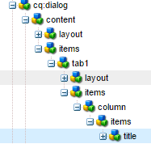

cq:dialog

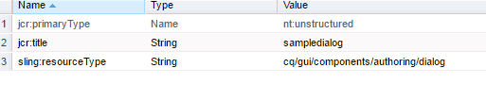

content

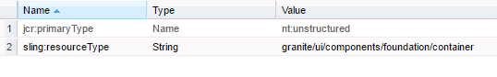

layout

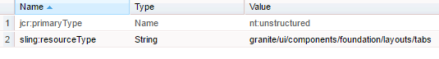

tab

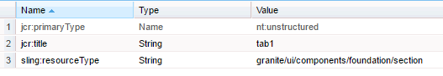

layout (under tab node)

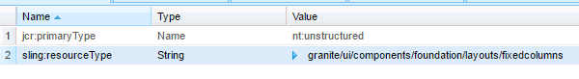

column

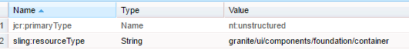

Title/text display

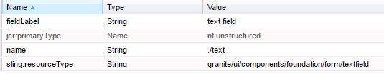

sling:resourceType values that are used to create the component :

|  |  |
| --- | --- |
| **Sling:resourceType** | **Description** |
| granite/ui/components/foundation/container | Defines a container for the dialog |
| granite/ui/components/foundation/layouts/tabs | Defines a tab that is used in the dialog |
| granite/ui/components/foundation/section | Defines a section within a tab. |
| granite/ui/components/foundation/layouts/fixedcolumns | Defines fixed columns. |

Touch UI Dialog

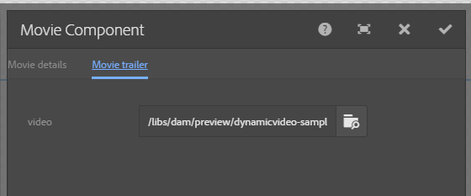

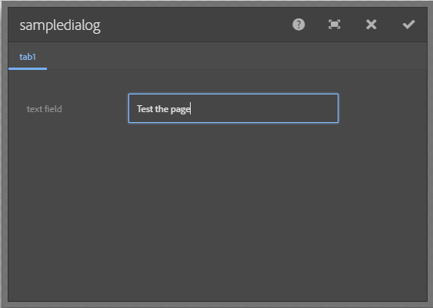

Classic dialog xtype and its corresponding touch UI resource type:

|  |  |
| --- | --- |
| **ExtJS xtype** | **Granite UI resource type** |
| button | granite/ui/components/foundation/form/button |
| checkbox | granite/ui/components/foundation/form/checkbox |
| componentstyles | cq/gui/components/authoring/dialog/componentstyles |
| cqinclude | granite/ui/components/foundation/include |
| datetime | granite/ui/components/foundation/form/datepicker |
| dialogfieldset | granite/ui/components/foundation/form/fieldset |
| hidden | granite/ui/components/foundation/form/hidden |
| html5smartfile, html5smartimage | granite/ui/components/foundation/form/fileupload |
| multifield | granite/ui/components/foundation/form/multifield |
| numberfield | granite/ui/components/foundation/form/numberfield |
| pathfield, paragraphreference | granite/ui/components/foundation/form/pathbrowser |
| selection | granite/ui/components/foundation/form/select |
| sizefield | cq/gui/components/authoring/dialog/sizefield |
| tags | granite/ui/components/foundation/form/autocomplete cq/gui/components/common/datasources/tags |
| textarea | granite/ui/components/foundation/form/textarea |
| textfield | granite/ui/components/foundation/form/textfield |

Classic dialog node type and its corresponding resource type:

|  |  |
| --- | --- |
| **Node type** | **Granite UI resource type** |
| cq:WidgetCollection | granite/ui/components/foundation/container |
| cq:TabPanel | granite/ui/components/foundation/container granite/ui/components/foundation/layouts/tabs |
| cq:panel | granite/ui/components/foundation/container |